**Report on the Market Intelligence Model**

**1. Introduction**

This report provides a comprehensive overview of the **Market Intelligence Model** we developed. The system integrates multiple functionalities to offer actionable insights into market trends, competitor movements, industry forecasts, and startup ecosystem analysis. Each component is designed to be modular, allowing for future expansion and seamless integration with additional data sources.

**2. Objectives**

1. **Market Trend Analysis:**
   * Fetches and processes the latest business news headlines from external APIs (e.g., NewsAPI).
   * Applies sentiment analysis to gauge overall market sentiment.
2. **Competitor Tracking:**
   * Monitors key competitors by querying relevant news or data sources (NewsAPI, social media, etc.).
   * Flags competitor announcements, product launches, and funding activities.
3. **Industry Forecasting:**
   * Leverages historical (or synthetic) data to predict future industry metrics using a time-series forecasting model (Prophet).
   * Provides confidence intervals for decision-making under uncertainty.
4. **Startup Ecosystem Analysis:**
   * Identifies emerging startups, their industries, funding, and locations.(Currently With Dummy Datasets).
   * Optionally integrates real data from platforms like Crunchbase for deeper ecosystem insights.

**3. Architecture & Components**

The system follows a **modular architecture**, ensuring that each feature can be developed and maintained independently:

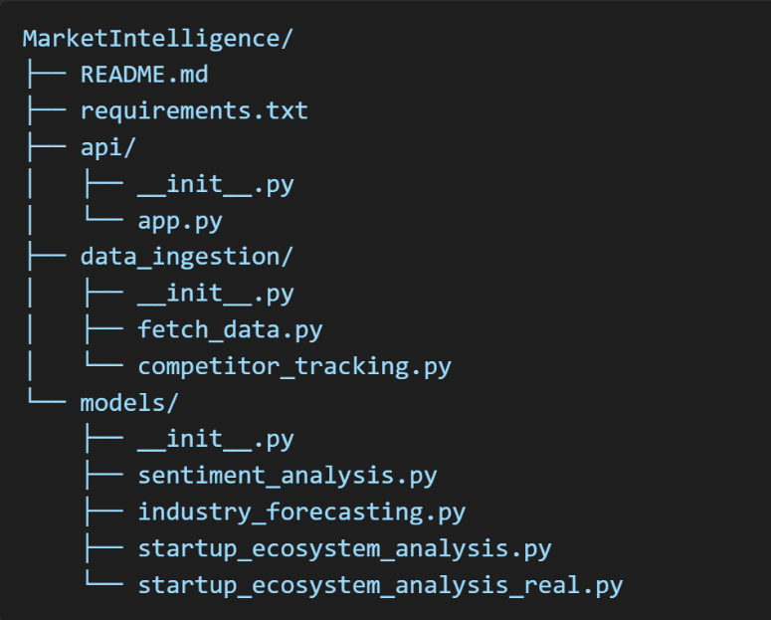

**3.1. api/ Layer**

* **app.py:**  
  Houses the Flask application. It exposes RESTful endpoints for each core function:
  + **/market-trends** to analyze market news and sentiment.
  + **/competitors** to track competitor-specific news.
  + **/industry-forecast** to provide industry forecasts.
  + **/startup-ecosystem** to offer startup ecosystem insights.

By default, these endpoints return JSON responses, making it easy to integrate with various front-end applications or data visualization tools.

**3.2. data_ingestion/ Layer**

* **fetch_data.py:**  
  Contains a function to retrieve top business headlines via the NewsAPI. It handles HTTP requests, checks response status, and returns JSON data for further processing.
* **competitor_tracking.py:**  
  Fetches news articles for specified competitors using the “everything” endpoint of NewsAPI (or other relevant data sources). This module can be expanded to include additional data streams (e.g., social media, company websites).

**3.3. models/ Layer**

1. **sentiment_analysis.py:**
   * Uses **TextBlob** to compute sentiment scores (polarity and subjectivity) for text inputs.
   * Integrated into the /market-trends and /competitors endpoints to annotate news articles with sentiment insights.
2. **industry_forecasting.py:**
   * Implements a time-series forecasting model with **Prophet**.
   * Generates synthetic historical data in this demonstration, but can be adapted to real datasets (e.g., revenue, market size, user growth).
   * Returns forecast values (yhat) along with lower (yhat_lower) and upper (yhat_upper) confidence intervals.
3. **startup_ecosystem_analysis.py:**
   * We Have Provided a static (dummy) dataset of startups, simulating location, funding, and stage details.
   * Useful as a baseline or fallback when real data sources are unavailable.
   * You Can Use Real Data from Sources Like CrunchBase APIs (Subscription) Or AngelList.

**4. Data Flow**

1. **Request to Flask Endpoint:**  
   A user or system sends an HTTP GET request to one of the endpoints (e.g., /market-trends).
2. **Data Ingestion:**
   * For **market trends** and **competitor tracking**, the system calls NewsAPI using stored API keys (loaded from .env).
   * For **startup ecosystem**, it either returns static data or queries the Crunchbase API, depending on the user’s request parameters.
3. **Processing & Analysis:**
   * The fetched news articles are passed to the **TextBlob**-based sentiment analysis module.
   * For **industry forecasting**, the system uses Prophet to generate a future forecast.
   * For **startup ecosystem**, data is aggregated (either static or real) and returned in a structured format.
4. **Response Generation:**
   * Flask compiles the processed data (articles with sentiment, forecast data, or startup lists) into a JSON response.
   * The user receives a JSON payload containing the requested insights.

**5. Key Functionalities**

1. **Market Trend Analysis:**
   * **Endpoint:** /market-trends
   * **Process:** Retrieves top business headlines → runs sentiment analysis → returns JSON with sentiment scores for each article.
   * **Use Case:** Gauge overall market mood and detect shifts in public perception.
2. **Competitor Tracking:**
   * **Endpoint:** /competitors
   * **Process:** Queries NewsAPI’s “everything” endpoint with competitor names → runs sentiment analysis → returns JSON with competitor-related news and sentiments.
   * **Use Case:** Monitor competitor moves, product launches, and brand sentiment.
3. **Industry Forecasting:**
   * **Endpoint:** /industry-forecast
   * **Process:** Generates a time-series forecast for a given industry using Prophet → returns predictions (yhat) and confidence intervals (yhat_lower, yhat_upper).
   * **Use Case:** Predict future market trends, potential demand, or growth rates.
4. **Startup Ecosystem Analysis:**
   * **Endpoint:** /startup-ecosystem
   * **Process:** Depending on user choice, returns either static or real data from Crunchbase → organizes it by startup name, industry, funding, and stage.
   * **Use Case:** Identify emerging startups, track funding rounds, and understand ecosystem composition.

**6. Conclusion**

The **Market Intelligence Model** detailed in this report provides a **unified platform** for collecting and analyzing crucial market information. By modularizing each function—data ingestion, sentiment analysis, forecasting, and ecosystem analysis—the system is:

1. **Extensible:** New data sources (e.g., social media, additional APIs, X(Formerly Twitter) can be integrated without overhauling existing components.
2. **Maintainable:** Each module has a clear responsibility, simplifying debugging and updates.
3. **Scalable:** It can handle increased data volume or additional endpoints by employing cloud-based solutions and best practices.

With this foundation, organizations can make **data-driven decisions** regarding market trends, competitor strategies, industry trajectories, and emerging startup opportunities.